GY 110: People, Places, & Environment
Fall 2018
Instructor: Dr. Wanyun Shao
Email: wshao1@ua.edu Phone: 205-348-2969
Time: 1:00 pm – 2:15 pm TR Location: Gordon Palmer Hall 206
Office hours: 11:00 am – 12:30 pm TR
www.wanyunshao.com

Course Description
As one of the two major branches of Geography, Human Geography is concerned with the relationships people have with their places and environments. For global citizens living in the 21st century, being confronted with daunting challenges such as environmental degradation, economic inequality, major demographic shifts, and political polarization on varying geographic scales, it is necessary to understand how human choices can steer their relationships with their places and environments in totally different directions. During this course, students will embark on an intellectual journey to explore the dynamics of people, places, and environment.

Throughout this course, we will delve into various topics including: basics of geography, population and health, migration, folk and popular culture, languages, religions, ethnicities, political geography, food and agriculture, development, industry and energy, services and settlements, and urban patterns.

Required Text
The Cultural Landscape: An Introduction to Human Geography, 12th Edition by James Rubenstein.

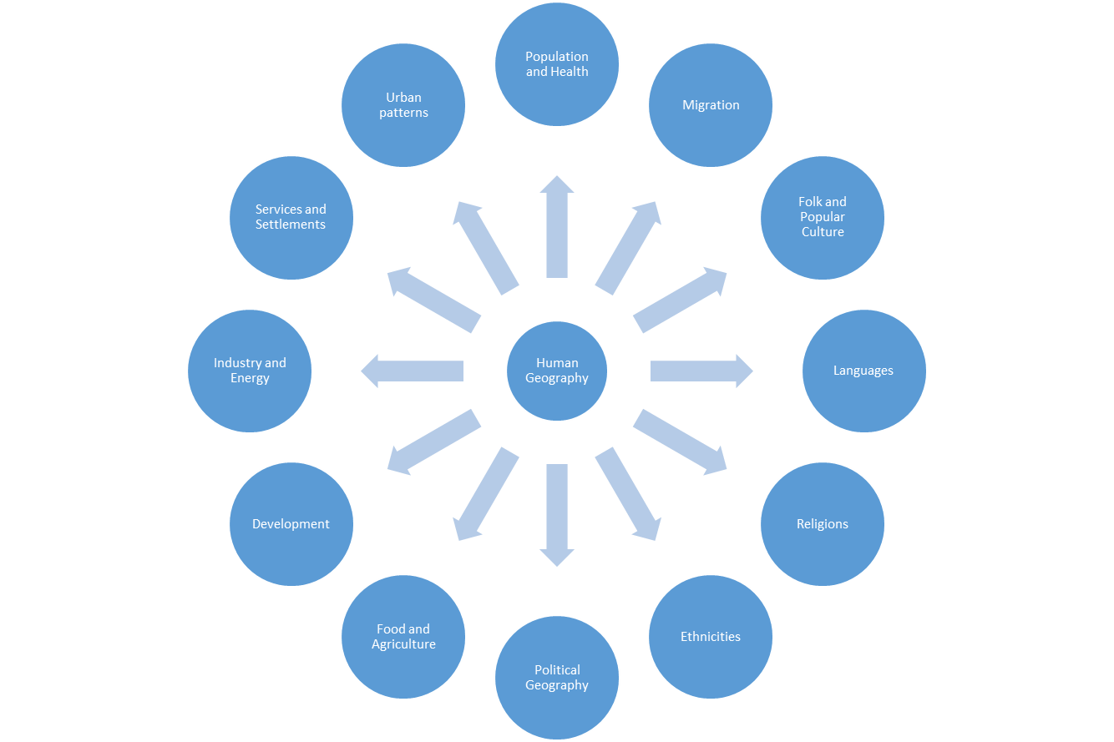

Figure 1. Course Structure
Student Learning Objectives and Outcomes
By the end of this course, your understanding of the relationship between people and environment will be updated. You will be able to identify social, cultural, political, and economic phenomena in a spatial context. Moreover, you will be able to better appreciate how place provides the community an identity and a platform on which we survive, evolve, and thrive. You will be able to detect the ubiquitous influence of globalization. You will be more conscious of the impact of human activity on environment.

Exams
There will be two noncumulative examinations including a mid-term exam and a final exam. Each will be worth 100 points. Bring Scantron form # 882-E to class each time there is an exam. You are not allowed to leave the class during an exam until you have completed it.

Quizzes
There will be six reading quizzes during this course. Each quiz is worth 30 points. Each quiz covers a very specific topic. Bring Scantron form # 882-E to class each time there is a quiz. You are not allowed to leave the class during a quiz until you have completed it.

Course Grading
Exams (2) 100 points per exam =200 points
Quizzes (6) 25 points per quiz =150 points
Attendance 30 points =30 points
Total =380 points

Figure 2. Grade Distribution

Semester Grades Are Determined Using This Scale
342-380 90-100% =A
304-341 80-89% =B
266-303 70-79% =C
228-265 60-69% =D
<228 59% or less =F

Note: students are required to take all the quizzes and exams. Failure to complete all of the required quizzes and exams may result in a grade of F for the course. If you know ahead of time that you would miss a quiz or an exam, please notify me of your absence at least two weeks in advance. If your absence for a quiz or an exam is due to a sudden and unexpected event, a make-up quiz or exam will be considered only upon receipt of a documentation for an absence.

Email Policy
I WILL NOT respond to messages sent by any email service other than UA E-mail. AND ALWAYS PUT the course number on the subject line.

Disability Accommodations
Students who need accommodations are asked to arrange a meeting during office hours to discuss your accommodations. If you have a conflict with my office hours, an alternate time can be arranged. To set up this meeting, please contact me by e-mail. If you have not registered for accommodation services through the Office for Disability Services (ODS), but need accommodations, make an appointment with ODS, Houser Hall, Room 1000, or call 205-348-4285 or email ODS at ods@ua.edu.

Academic Dishonesty
Academic dishonesty is a very SERIOUS and UNFORGIVABLE offence under UA policy. Academic dishonesty will result in an automatic “F.” A student may be denied an academic degree if found guilty of academic dishonesty. This is noted permanently on the student’s educational record. Please refer to the UA Student Handbook on Academic Dishonesty or feel free to contact me for further clarification. Conduct in the Classroom In the classroom, I expect you to show respects for me and your classmates. All students need a comfortable, safe, and distraction-free learning environment. If you engage in any behavior that can be disruptive or disrespectful, I will ask you to discontinue immediately or leave the classroom. I have NO tolerance for cell phone use in the classroom. If you have to use your iPads or laptop to take notes, you are not permitted to engage in activities that are irrelevant to the class.

